# Plasticity of Breeding in Foothill Yellow-legged Frogs (*Rana boylii*) Linked to Predictable Environmental Cues in the Sierra Nevada

Authors:

Peek, Ryan A.1

Yarnell, Sarah .1

Affiliations:

1Center for Watershed Sciences, University of California, Davis

## *Abstract*

*Rana boylii* (Foothill Yellow-legged Frog) requires specific environmental cues (flow predictability and water temperature) to initiate breeding. These cues are similar across a wide geographic range, despite shifts in the timing of these seasonal cues annually. For *R. boylii*, breeding plasticity may be viewed as a behavioral response to environmental cues from predictable recession rates, timing of receding flows, and water temperature. We show data demonstrating differences in inter-annual breeding timing in *R. boylii* between wet years and dry years, as well as regional differences observed in coastal and mountain watersheds, including some of the earliest and latest oviposition documented in the Sierra Nevada. *R. boylii* shows high plasticity in the timing (in days) of breeding, but it still remains strongly correlated with hydrological cues such as the rate of the natural spring snowmelt recession in the Sierra Nevada (approximately 10 cm per week) and the minimum average weekly water temperature. On average, rain-driven watersheds in coastal *R. boylii* populations initiate breeding as soon as early March, over a month earlier than snowmelt systems in the Sierra Nevada. A summary of over 10 years of breeding data for *R. boylii* across California shows the range in breeding timing can vary by four months, from early March to early July. Conservation management in regulated rivers for crucial breeding and rearing periods may be enhanced by more accurately mimicking environmental cues such as the timing of flows and consistency of recession rates in the spring. This research helps expand current knowledge about breeding phenology for this species and informs future management planning and climate change monitoring efforts by more accurately defining the environmental cues required for *R. boylii* breeding in the Sierra Nevada.

*Key Words.—*environmental flows; hydrograph; management; natural flow regime; oviposition; river; sensitive species; water temperature

Introduction

Variability in ecosystems is an important component which provides heterogeneity through time and space (Naiman et al. 1988; Benda et al. 2004; Poff et al. 2010). Organisms in stochastic systems must evolve with physiological or life history adaptations that permit flexible responses to changing conditions over time (Gotthard and Nylin 1995; Tufto 2000). Amphibians often have highly variable behavior because they are particularly sensitive to changes in the ecosystem due to their physiology and ontogeny (Davidson et al. 2002; Beebee and Griffiths 2005), thus the ability to utilize environmental variables as life history cues is especially important. Many studies, largely associated with lentic breeding amphibians, have identified an array of plastic responses to different environmental cues such as changing hydroperiod (Laurila and Kujasalo 1999; Lind and Johansson 2007), predation (Relyea 2002; Richardson 2002), and competition (Kupferberg 1997; Barnett and Richardson 2002). For some amphibian species, environmental cues can have stronger influences on breeding and development than other correlative factors such as predation and competition. Laurila and Kujasalo (1999) observed increased development rates in the common frog (*Rana temporaria*) specifically in response to pond-drying, and not due to increased temperature or presence of predators. Other studies have shown plasticity in the timing of the larval period (Merilae et al. 2000), larval body shape (Relyea 2002), and size at metamorphosis (Werner 1986; Alford and Harris 1988; Newman 1992) related to cues from predation (Gomez-Mestre et al. 2008), pond-drying (Denver et al. 1998; Merilae et al. 2000), hydrology (Jakob et al. 2003), temperature (Orizaola and Laurila 2009), and habitat structure (Rudolf and Rodel 2005). Yet little is known about plasticity of lotic amphibian species in relation to specific environmental cues.

In highly dynamic riverine environments, organisms must constantly adapt to temporal and spatial changes. Plastic behavioral responses to heterogeneous environments can be adaptive for an organism in many ways, such as increasing the probability for survival of progeny, utilizing optimal feeding habitat, minimizing predation, or reducing exposure to seasonal stresses like high temperatures, flooding, or fire (Sinervo and Adolph 1994; Nicol 2006; Orizaola and Laurila 2009). Michel (2012) suggests plasticity may be favored when environmental factors vary spatiotemporally, habitat suitability is predictable through reliable cues, organisms have limited dispersal between dissimilar habitats, and differential fitness associated with different phenotypes exists among contrasting environments. Thus, biological plasticity may be tied to environmental cues that forecast stable conditions suitable for sensitive life history stages. Reed et al. (2010) observed the importance of reliable cues under high environmental stochasticity; when cue reliability was low, plastic phenotypes within a population were less successful at tracking environmental fluctuations.

For lotic species inhabiting Mediterranean climates, typical of California, the general seasonal pattern of wet winters and dry summers is predictable across years; however, individual water year types may vary from very dry to very wet, and are associated with differences in the magnitude and timing of precipitation and correlated shifts in water temperature. In rivers with natural flow regimes (Poff et al. 1997), predictable flow patterns, such as the spring snowmelt recession in the Sierra Nevada of California that creates a gradual decrease in discharge and increase in water temperature, provides distinct and reliable cues for reproduction in fish and amphibians, recruitment in riparian vegetation and diversity in benthic macroinvertebrates (Yarnell et al. 2010). Because these hydroclimatic conditions can vary from year to year, the timing of associated cues may also vary, and therefore lotic aquatic species reliant on suitable breeding conditions must exhibit some degree of plasticity in order to reproduce successfully.

Environmental stressors can play important roles in a species life history. Factors such as seasonal temperature changes, desiccation, or changes in flow can affect selection pressure on physiological adaptations or life history traits. For example, high elevations in the Sierra Nevada may remain under snow for over seven months annually, and thus the Sierra Yellow-legged Frog (*Rana sierrae*) larvae may overwinter multiple years in order to maximize development before metamorphosis (Matthews and Pope 1999). In aquatic systems with unpredictable flow patterns, some species exhibit adaptations (either morphological or behavioral), which increase fitness and potential survival (Lytle and Poff 2004; Kupferberg et al. 2012).

Studies have shown environmental cues like degree day (Neuheimer and Taggart 2007; Timm et al. 2007), day length (Saenz et al. 2006), hydroperiod (Laurila and Kujasalo 1999), water temperature and flow (Keefer et al. 2008) are important triggers for crucial phases in species development or life history. In naturally dynamic lotic systems like rivers, species must be plastic to successfully persist under seasonal and annual variability. For the river breeding *Rana boylii* (Foothill Yellow-legged Frog), we hypothesize the most important environmental cues are gradual rates of receding flow and water temperature, which *R. boylii* have adapted to utilize as predictable signals of suitable periods for the initiation of egg deposition (oviposition). While previous data has shown cues such as water temperature and receding flow are important (Zweifel 1955; Kupferberg 1996; Lind et al. 1996; Kupferberg et al. 2012), we suggest that *R. boylii* have adapted a plastic response (breeding timing) to these environmental signals to ‘forecast’ life history periods critical to reproductive success.

The lotic frog R. boylii historically occurred in streams and rivers from Southern Oregon to northern Baja California west of the Sierra-Cascade crest across a range of elevations from sea level to 1830 m (Stebbins 2003) (Figure 1). However, population declines have been documented across the former range of this species, particularly in southern California and the Sierra Nevada where it has been extirpated from approximately 60 percent of its historic range (Jennings et al. 1994; Davidson et al. 2002; Lind 2005). In the Sierra Nevada, R. boylii has evolved to breed in synchronicity with seasonal spring snowmelt, generally timing egg deposition to occur during the period of runoff represented by the descending limb of the hydrograph when gradually receding flows coincide with warming water temperatures (Kupferberg 1996; Lind et al. 1996; Yarnell et al. 2010). Following emergence, tadpoles grow in the warm low flow conditions typical of California’s dry season and metamorphose in the fall prior to the onset of winter rains. Reproductive success depends on the ability of an individual to select the appropriate window for oviposition in spring that maximizes over-winter survival—egg masses are at risk of scour from late spring storms if they are laid too early in spring, while growth following metamorphosis may be limited if eggs masses are laid too late in the summer (Kupferberg et al. 2008).

In rivers in California, particularly in the Sierra Nevada, perhaps the most critical environmental stressor for the lotic breeding *R. boylii* is river regulation (Lind et al. 1996; Kupferberg et al. 2008; Kupferberg et al. 2012). River regulation, and more specifically, regulation associated with hydropower generation, has been implicated as a cause of fundamental changes to downstream aquatic ecosystems (Power et al. 1996; Rehn 2009; Moyle et al. 2011). Approximately 30 percent of the total annual runoff in California drains from the watersheds of the Sierra Nevada, and this water is captured for downstream use where it is often delivered at times asynchronous to natural seasonal timing (Marchetti and Moyle 2001; Grantham et al. 2010). Aseasonal changes in regulated flow regimes due to hydropower, water supply, or recreation miscue or eliminate the important environmental cues around which native aquatic species have evolved (Yarnell et al. 2010; Yarnell et al. 2012).

Regulated bypass river reaches typically alter the natural hydrograph by capturing or diverting winter and spring runoff, thereby reducing or eliminating the natural spring recession of flow, while aseasonal pulsed flows from hydropower peaking or summer recreational boating releases cause large sudden changes in water depths, further disrupting natural spring and summer flow regimes.

Regulated rivers have different hydrologic signatures than those that remain unregulated (undammed), and often these signatures exhibit patterns in the timing, magnitude, and duration of flow that are out of phase with the seasonally driven patterns observed in unregulated rivers (Marchetti and Moyle 2001; Grantham et al. 2010). These large-scale hydrologic changes from dams have significantly altered the highly seasonal yet predictable flow related cues with which native lotic specieshave evolved. For lotic species such as *R. boylii* that rely on some degree of plasticity to maximize larval development during the predictable flows and warm temperatures associated with Mediterranean summers in California, river regulation can severely limit reproductive success (Lind et al. 1996; Kupferberg et al. 2012).

We suggest *R.boylii* use specific environmental cues (flow recession rate and water temperature) to project the onset of suitable and stable hydraulic and thermal periods for spring breeding as these signals can be consistently utilized across a wide geographic range, despite considerable shifts in the timing of these seasonal cues from year to year. As a result, this species breeds in very similar hydrologic conditions across watersheds, states and years, despite a highly variable geographical and environmental gradient across the *R. boylii* range (Kupferberg 1996; Lind 2005). For *R. boylii*, this breeding plasticity may be viewed as a behavioral response to predictable recession rates, timing of receding flows, and water temperature. We show data demonstrating extreme differences in inter-annual breeding timing in *R. boylii* between wet years and dry years, as well as regional differences observed in coastal and mountain watersheds, including some of the earliest and latest oviposition documented in the Sierra Nevada. From a conservation perspective, this plasticity may provide resilience to changes in temporal variability and timing expected from climate warming. Therefore maintaining the timing and pattern of these crucial environmental cues in managed systems is important for population persistence.

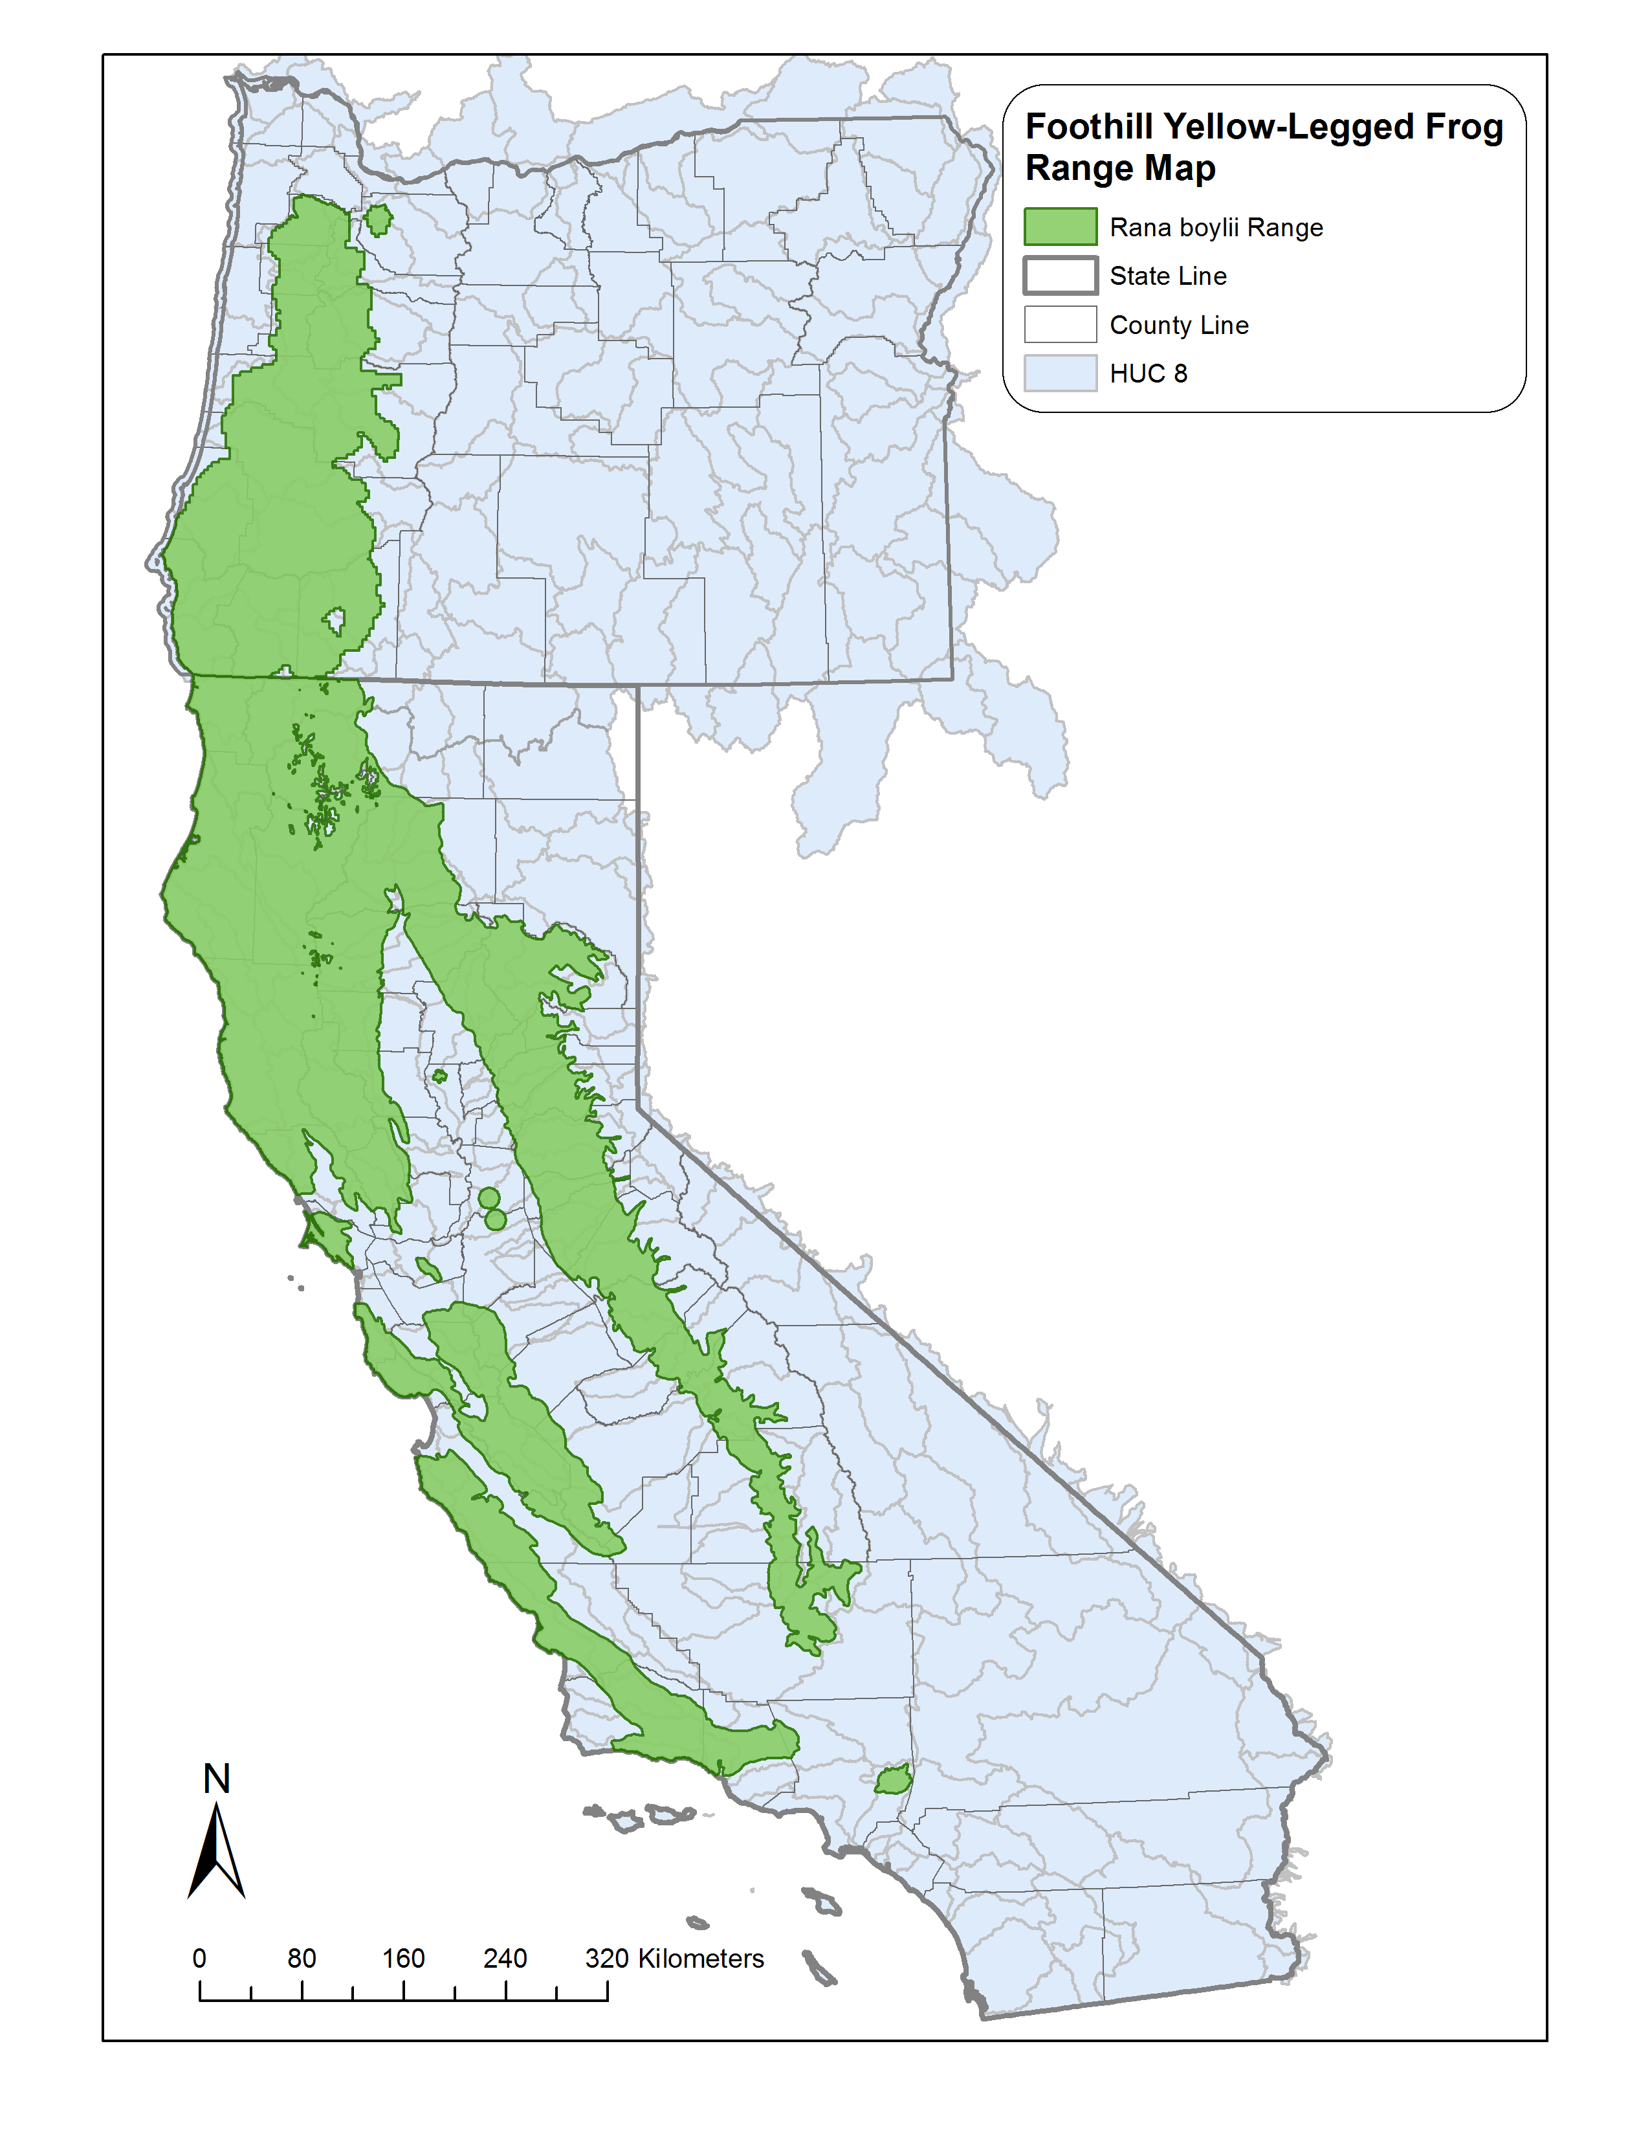

**Figure 1**. Approximate range of *Rana boylii* CDFW or Jennings and Hayes 1994?.

***Ecological Cues.—***For R. boylii, breeding plasticity may be viewed as a behavioral response to environmental cues. Furthermore, we suggest R. boylii utilizes the timing and rate of receding flows (from snowmelt in the Sierra Nevada or precipitation along the coast) in conjunction with warming water temperatures because these cues successfully ‘forecast’ life history periods critical to reproductive success regardless of geographic location. In streams and rivers, the timing of these cues from year to year can be starkly different due to hydroclimatic patterns associated with Mediterranean environments (e.g., potentially wet one year and dry the next) and differences in the precipitation patterns (rain or snow driven).

METHODS?

Predictable Rates of Sierra Nevada Runoff.—In undammed and unregulated rivers in the Sierra Nevada, the spring snowmelt recession links high winter flows to low summer baseflows and is a consistent and predictable portion of the annual hydrograph (Yarnell et al. 2010). Consequently, the spring snowmelt recession is an important resource to both riverine ecosystems and California’s water supply. In an analysis of eight unregulated watersheds across the Sierra Nevada, Epke (2011) found the shape of the spring snowmelt recession was consistent from year to year across an average period of record of 70 years. On average, the spring recession in the Sierra Nevada lasted 75 days and began in mid-May, with small differences in timing due to elevation (lower elevation recessions begin earlier). The daily percent change in flow during the recession generally started at approximately 10 percent per day and decreased to four percent per day near the end of the recession (Epke 2011). Despite differences in elevation, watershed size and latitude, the snowmelt recession in the Sierras is extremely predictable in its shape and pattern.

Variations in regulated spring flow regimes can be moderate, as observed on the Rubicon where daily recession rates can average 15 percent per day in drier years, or extreme, as observed on the SF Yuba where flow reductions following high flow spill in 2011 averaged 80% per day until flows returned to baseflow.

In the Sierra Nevada, *R. boylii* have evolved to depend on the stability of the snowmelt recession rate for successful reproduction. *Rana boylii* require approximately two weeks for egg masses to hatch (Wheeler and Welsh Jr. 2008) and newly hatched tadpoles are not fully motile for approximately one week before developing the ability to swim. Therefore, *R. boylii* typically require oviposition habitat that remains wetted for an average of three weeks during the spring season to enable tadpoles to follow receding shorelines.

Data from previous studies in Sierran rivers shows that the majority of egg masses (74–94%) are deposited in water depths of less than 0.6 m and at least 40 percent are deposited in water depths less than 0.3 m (Bondi et al. 2013). Therefore, successful emergence as a tadpole requires that river flows do not decrease more than 0.3 m over three weeks during the spring recession (Lind and Yarnell 2011, unpub. report). On the unregulated North Fork [NF] American River, the average stage change that occurred during the spring recession at documented *R. boylii* breeding sites between 1998–2008 was 0.09 m per week, or approximately 0.3 m per three week period, despite varying water year types and discharge magnitude (Figure 2). This predictability in receding flows coupled with suitable channel habitat allows for highly successful reproductive conditions that *R.boylii* have evolved to take advantage of.

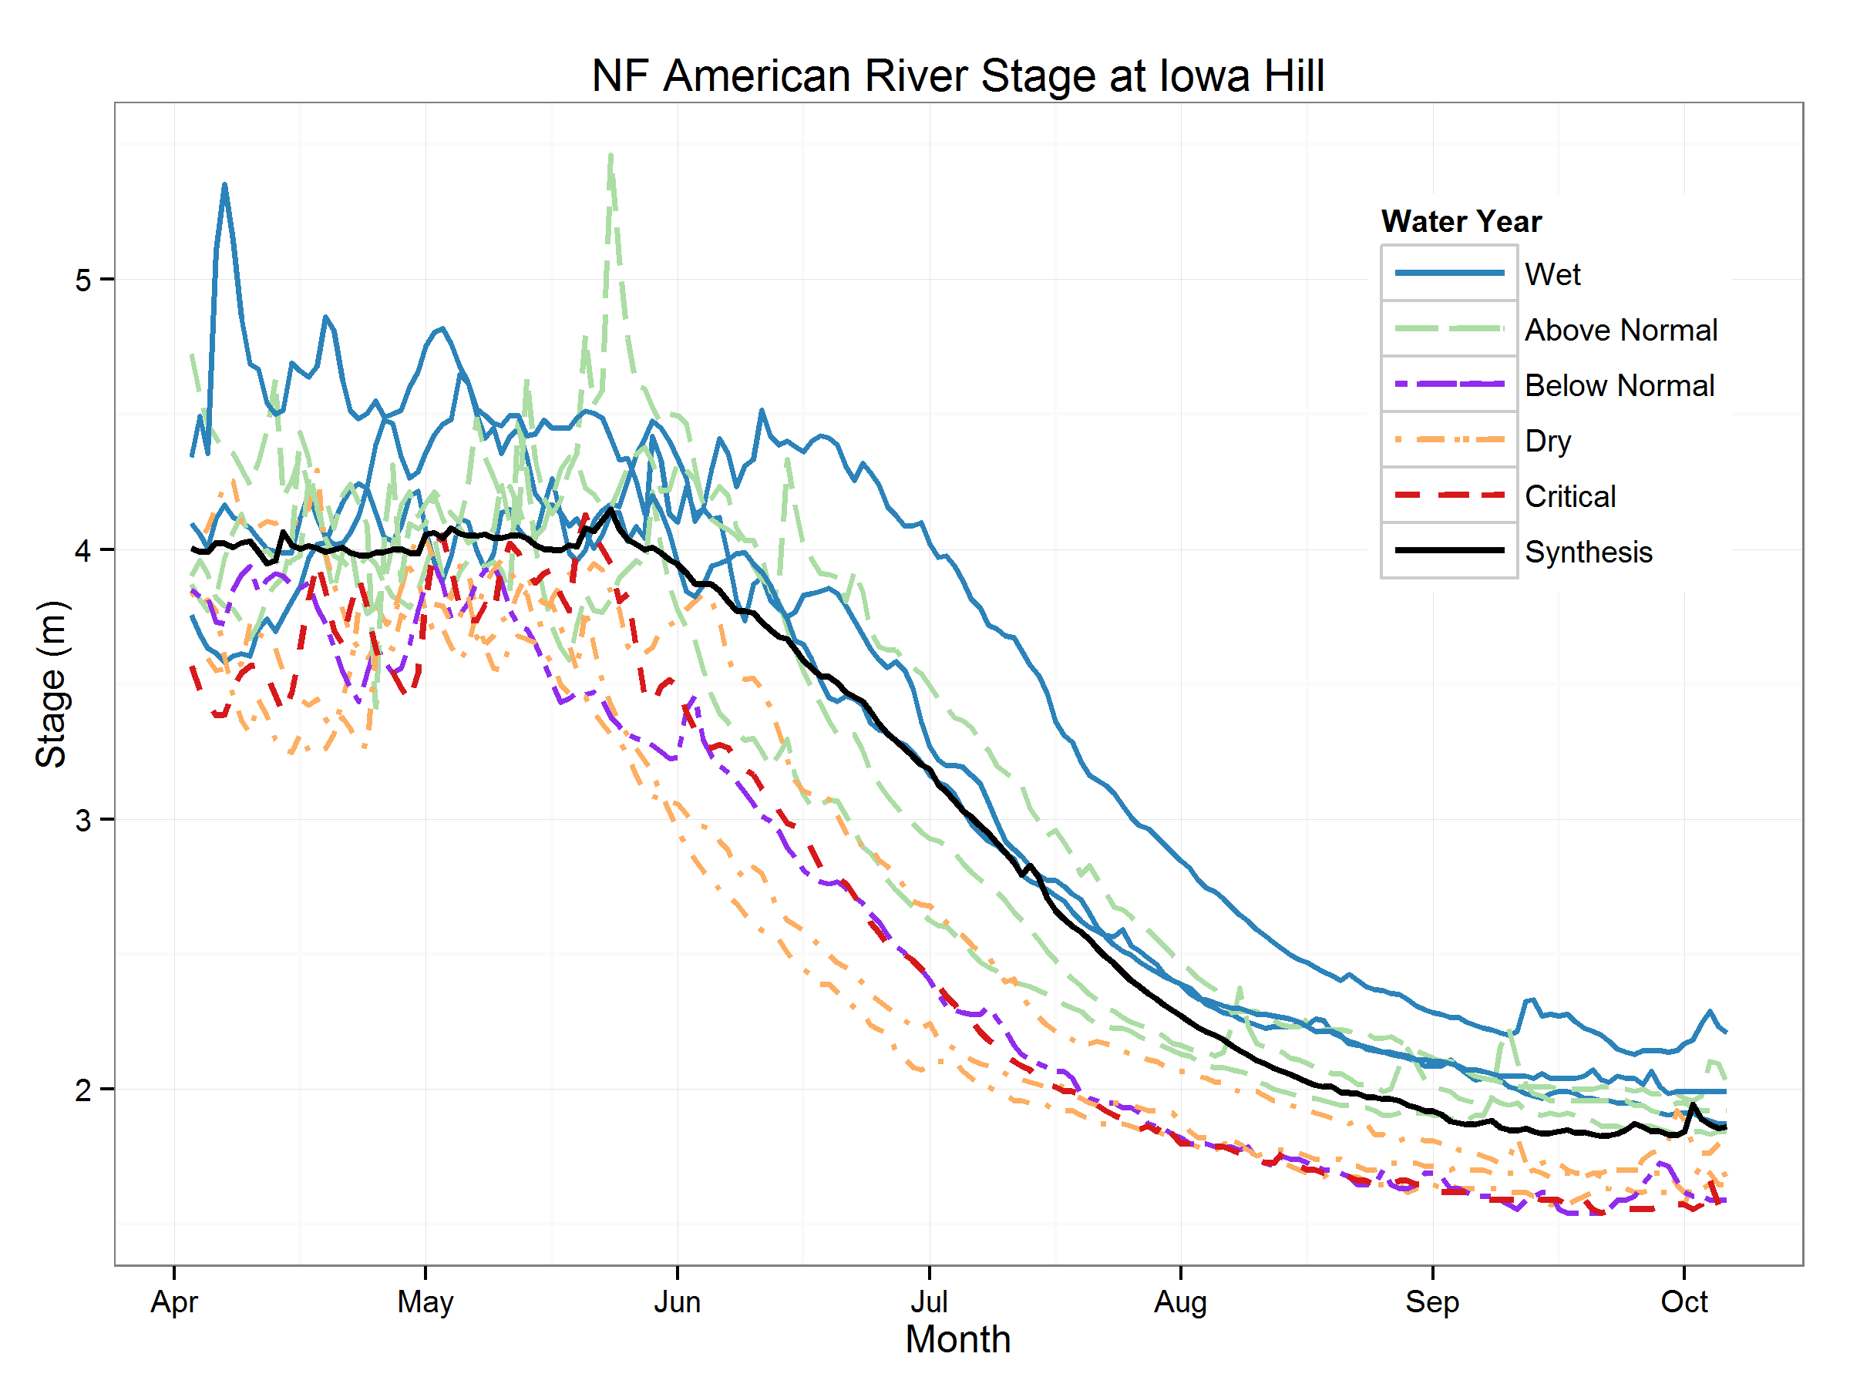

**Figure 2**. Stage change during the spring snowmelt recession in the NF American River at *R. boylii* breeding sites from 1998–2008, by water year type. Synthesis shows the mean stage change averaged over the entire period.

In coastal watersheds in California, groundwater instead of snowmelt is the primary hydrologic component driving the spring flow recession into summer. Seasonal spring rain can rapidly increase stream flow over short durations of time, but in general flow patterns in late spring and early summer predictably decline similar to Sierran rivers (Figure 3). On the South Fork [SF] Eel River, the average daily percent change in flow during the spring recession (March through July) in 2009 was 3% and in 2010, it was 4.8%. Studies of *R. boylii* oviposition in coastal systems have similarly documented the initiation of breeding when flows slowly recede after rain-driven events and water temperatures increase (Kupferberg 1996; Lind et al. 1996; Wheeler 2007; Gonsolin 2010).

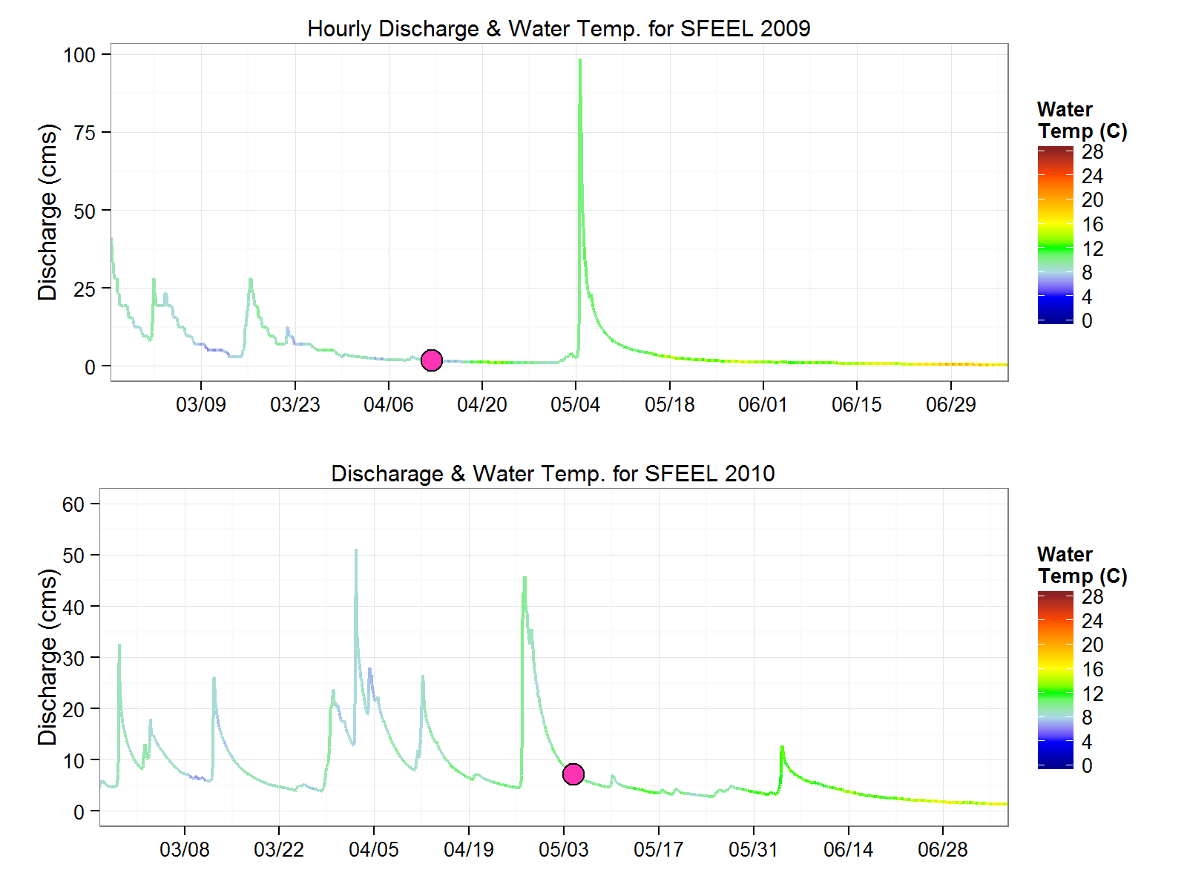

**Figure 3.** Thermohydrographs [stage colored by water temperature] of the SF Eel with initiation of earliest observed *R. boylii* breeding (solid circle).

Analysis

Timing of Spring Recession and Breeding.—Surveys of R. boylii oviposition have been conducted throughout California by many different groups, for various purposes, yet much of the data remain disparate and largely unreported. In an effort to compile records of the initiation of oviposition, we assessed all available records that included repeat egg mass surveys and surveys that occurred within the last ten years. Records were obtained dating back as far as 1917 (Storer 1925), yet few locations have more than two consecutive years of data (although see Kupferberg et al. (2012) and Kupferberg et al. (2009)). Based on data collected since 2002 from egg mass surveys throughout California, populations found along the California coast generally exhibited an earlier range of starting dates for initiation of breeding compared with populations in the Sierra Nevada. The average date of coastal oviposition was significantly earlier in the spring than in the Sierra Nevada (Kruskal-Wallis Rank Sum X2= 28.072, df=1, P > 0.001) (Figure 4, Table 1). The difference in dates is likely attributed to differences in hydroclimatic conditions between the coastal systems which have rain runoff in the spring, compared with Sierra Nevada systems, which are predominantly snowmelt driven.

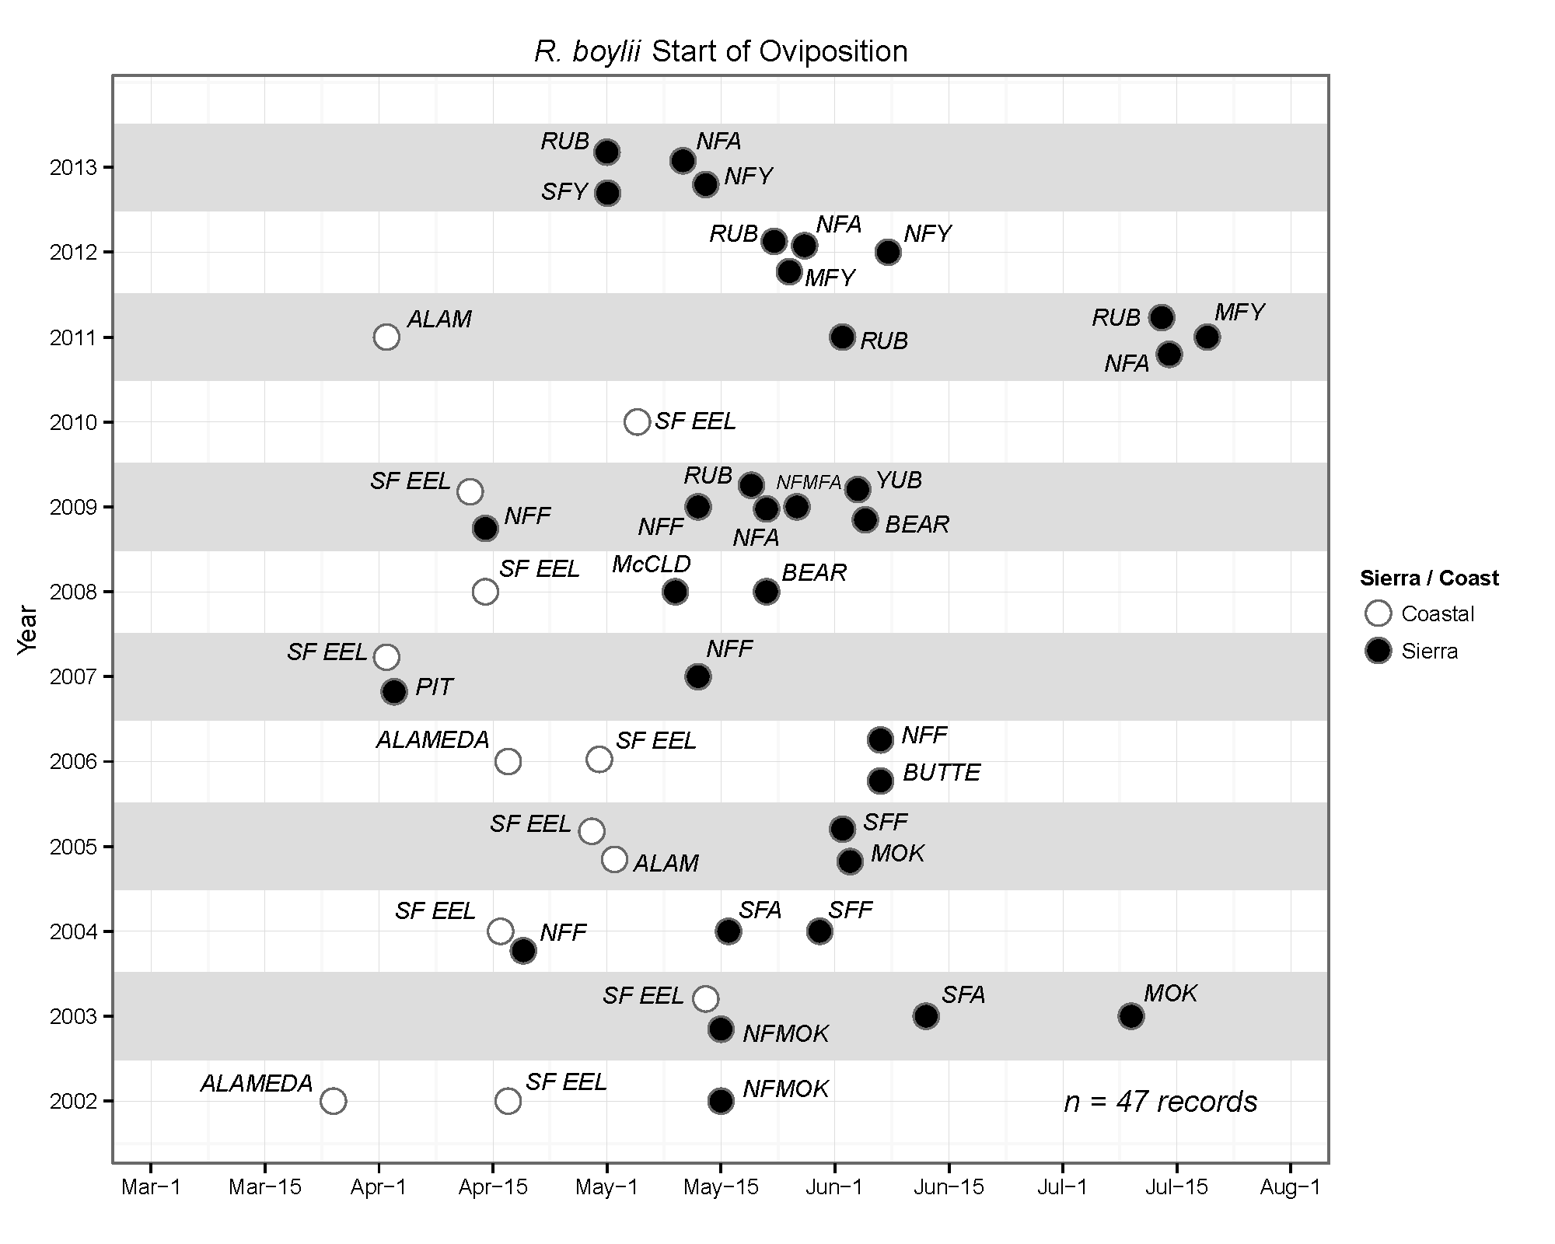

**Figure 4.** Range in date of initiation of oviposition (breeding) for *R. boylii* across multiple watersheds from 2002 to 2013 (RUB: Rubicon River; NFA: North Fork American; SFA: South Fork American; NFMFA: North Fork Middle Fork American; NFY: North Fork Yuba; MFY: Middle Fork Yuba; SFY: South Fork Yuba; ALAM: Alameda Creek; NFMOK: North Fork Mokelumne; MOK: Mokelumne; NFF: North Fork Feather; SFF: South Fork Feather; McCLD: McCloud). Published data from Storer 1925; Lind 2005; Kupferberg 2009; Peek 2010; Kupferberg et al. 2012; Bondi et al. 2013. Unpub. reportsa from ECORP; Nevada Irrigation District (NID); Pacific Gas and Electric Company (PG&E); Placer County Water Agency (PCWA); Stillwater Sciences; and US Forest Service.

aECORP Consulting, Inc. 2004. Results of the 2003 Foothill Yellow legged Frog (*Rana boylii*) and Mountain yellow legged frog (*Rana* *mucosa*) studies at the Spring Gap-Stanislaus project. Prepared for Pacific Gas and Electric Company, San Ramon, California, 115pp.

Nevada Irrigation District (NID) and Pacific Gas and Electric Company (PG&E). 2010. Technical Memorandum 3-6, FERC Project No. 2266. Special Status Amphibians: FYLF VES. Yuba-Bear Hydroelectric Project (FERC Project No. 2266-096) and Drum-Spaulding Project (FERC Project No. 2310-173). October 2010. Available from: <http://www.eurekasw.com/NID/Technical%20Memoranda/2009,%202010%20and%202011%20Technical%20Memoranda/Technical%20Memorandum%2003-06%20-%20Special-Status%20Amphibians%20-%20FYLF%20VES/Tech%20Memo%203-6%20-%20FYLF%20Surveys.pdf>

PG&E. 2002. Foothill yellow-legged frog (*Rana boylii*) studies in 2002 for PG&E's Pit 3, 4, and 5 Hydroelectric Project (FERC No. 233). 62pp.

PG&E. 2004a. Foothill yellow-legged frog (*Rana boylii*) egg mass, tadpole, and habitat surveys in the Pit 4 in 2003, Pacific Gas and Electric Company Pit 3, 4, and 5 Hydroelectric Project (FERC No. 233). 54pp.

PG&E. 2004b. Results of 2003 surveys and monitoring for foothill yellow-legged frogs (*Rana boylii*) within the Rock Creek-Cresta project area, North Fork Feather River, recreation and pulse flow biological evaluation. Prepared for San Ramon, California, Job 332/52, 65pp.

PG&E. 2007. Summary of Results for the 2006 Cresta and Poe Reach Amphibian Surveys.

PG&E. 2007. DeSabla-Centerville Hydroelectric Project. FERC No. 803-068 Supplemental Initial Study Report, Fifth Quarterly Progress Report, Volume II of III (Section 6.3).

PG&E. 2009. Technical Memorandum 29: Second Year Foothill Yellow-legged Frog Visual Encounter Surveys and Breeding Habitat Assessment in the Lower McCloud River, McCloud-Pit Project, FERC No. 2106.

PG&E. 2010. Draft Results of 2009 Surveys for Foothill Yellow-Legged Frogs on the Cresta and Poe Reaches of the North Fork Feather River. Job 475/153

Placer County Water Agency. 2011. AQ 12 – Special-Status Amphibian and Aquatic Reptile Technical Study Report – 2007. Application for New License. Volume 3, Exhibit E, Book 5, Supporting Document B. Filed with FERC February 23, 2011. Middle Fork American River Project (FERC Project No. 2079). Available from: <http://relicensing.pcwa.net/html/science/padreportaquatic.php>.

Stillwater Sciences. 2012. Analysis of long-term river regulation effects on genetic connectivity of foothill yellow-legged frogs (*Rana boylii*) in the Alameda Creek watershed. Final Report. Prepared by Stillwater Sciences, Berkeley, CA for SFPUC, San Francisco, CA.

**Table 1.** Oviposition statistics for Coastal and Sierra Nevada *R. boylii* populations

|  |  |  |
| --- | --- | --- |
| **2002–2013** | **Coast** | **Sierra Nevada** |
| Mean date of Earliest Oviposition | 10 Apr | 19 May |
| Minimum date of Earliest Oviposition | 08 Mar | 02 Apr |
| Maximum date of Earliest Oviposition | 13 May | 08 Jul |
| Range in date of Earliest Oviposition in days | 66 (±[SD] 15.15) | 97 ([±[SD] 19.31) |

Within the Sierra Nevada, the range in the beginning of *R. boylii* egg deposition is large as it varies from year to year. Based on records collected from various research projects and hydropower relicensing surveys dating back to 1992, the earliest recorded breeding in the Sierra Nevada appears to be in early-to-mid April 2007 and 2009 in the Pit and NF Feather River basins, and the next earliest record occurred on May 1, 2013 in the Rubicon River basin. Not only is the range in breeding initiation date large, but this variability in the initiation of oviposition can occur in the same basin at the same site in contiguous years.

Oviposition surveys were conducted from 2011 through 2013 at a set of monitoring sites in the Yuba and American watersheds as part of a concurrent project (Yarnell et al. 2013). Sites were selected to include both unregulated (undammed, no hydropower generation) and regulated (dammed with hydropower generation) river types. Each site was visually surveyed and snorkeled multiple times during spring and summer for *R. boylii* to determine date of initial oviposition, duration of oviposition period, and egg mass abundance. Stage and water temperature data were collected at 15 minute intervals for over three years at study sites in conjunction with surveys for *R. boylii* breeding.

We observed large shifts in date of initial oviposition across sites within a three-year period (Figure 5). For example, breeding was observed in late-April in the Rubicon River in 2012 and 2013, but we observed oviposition in July in 2011. This variability in oviposition timing reflects prevailing hydroclimatic conditions. In 2011, the snowpack in the central Sierra Nevada was 162% of normal as of 1 April, while 2012 and 2013 were much drier (approx. 50% of normal on 1 April).

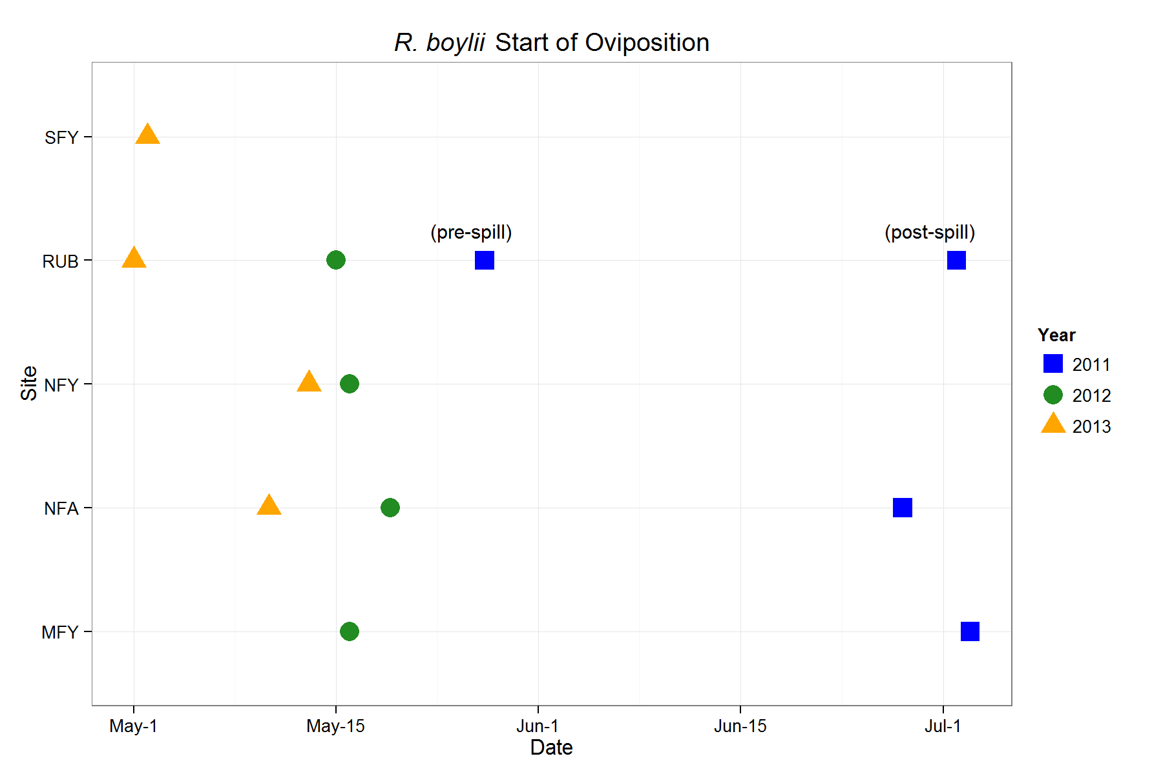

**Figure 5.** Earliest date of *R. boylii* breeding at selected study sites in Sierra Nevada from 2011 to 2013 [SFY: SF Yuba (regulated), RUB: Rubicon (regulated), NFY: NF Yuba (unregulated), NFA: NF American (unregulated), MFY: MF Yuba (regulated).

Data collected from 2011 through 2013 show a strong link between the initiation of *R. boylii* breeding and the snowmelt recession. Breeding consistently occurs as diurnal snowmelt pulses begin to recede into summer base flows, or as the spring hydrograph stabilizes into a descending limb (Figures 6a–6b). Despite differences between sites—some were dammed and regulated by hydropower (Rubicon, SF Yuba and MF Yuba), while others were unregulated (NF American and NF Yuba) — oviposition was accurately timed to the changes in the rate of receding flows indicating the start of one of the most stable periods of the seasonal hydrograph. Despite large shifts in snowmelt timing relating to differences in annual hydroclimatic conditions, initiation of breeding in the NF American consistently occurred when the average rate of decrease in stage was approximately 10 cm per week or less. We observed a similar pattern in the Rubicon River where initiation of breeding occurred after flows had stabilized near baseflow or were decreasing at rates of less than 5% per day. (Figure 6b).

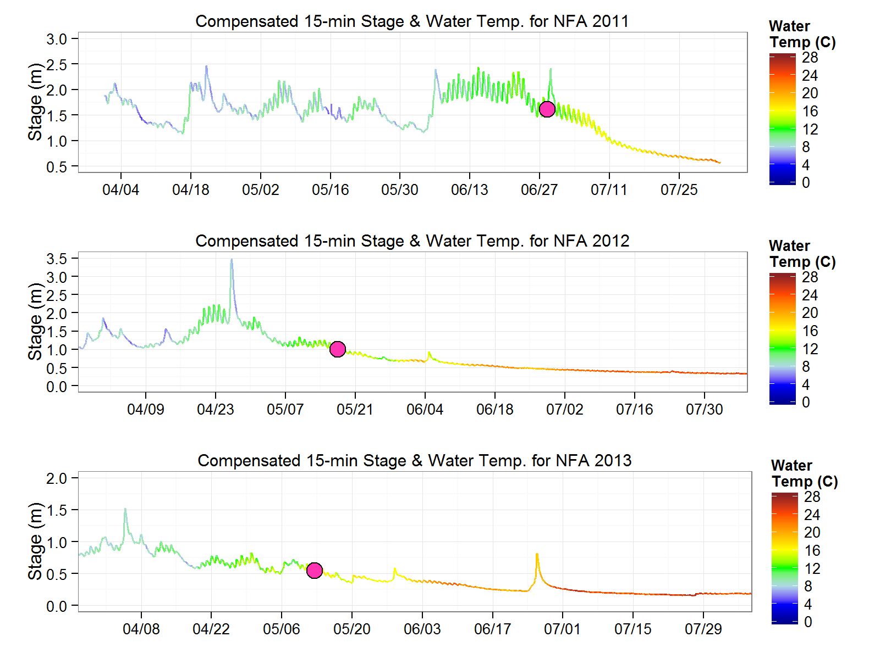

**Figure 6a.** Thermohydrographs [stage colored by water temperature] with earliest observed *R. boylii* oviposition (filled circles) at the unregulated NF American study site, 2011­­­–2013.

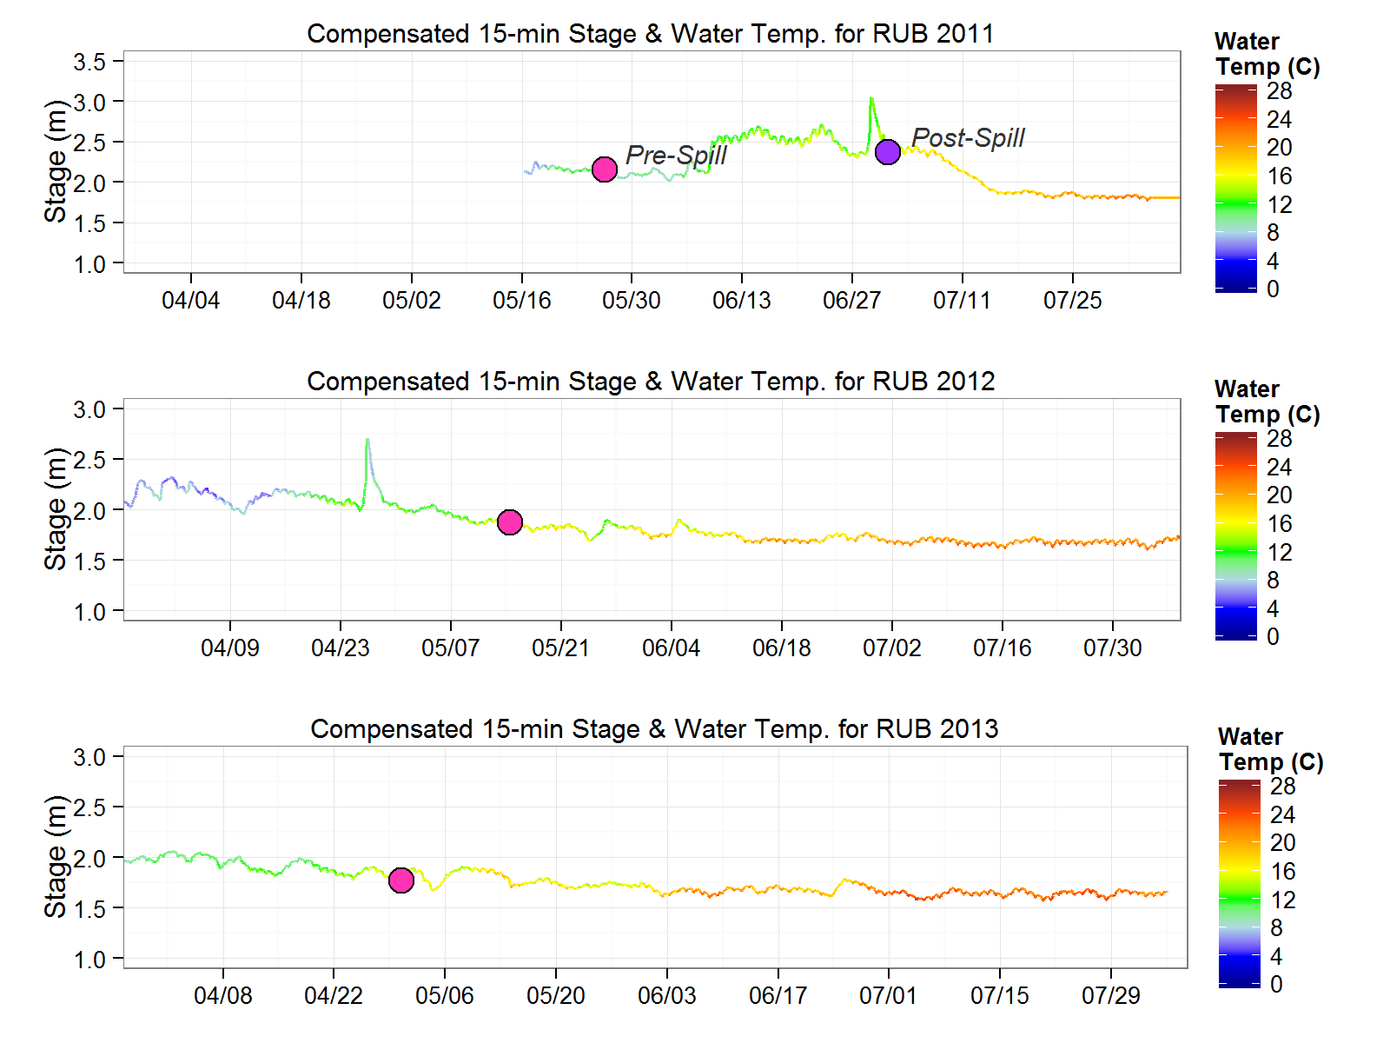

**Figure 6b.** Thermohydrographs [stage colored by water temperature] with earliest observed *R. boylii* oviposition (filled circles) at the regulated Rubicon study site, 2011­­­–2013.

Temperature Cues.—Temperature is an important abiotic signal for many aquatic organisms (Beschta et al. 1987; Null et al. 2013), and although regional variations in magnitude and timing of flow exist, seasonal water temperature patterns associated with spring snowmelt in the Sierra Nevada are highly predictable. While effects of water temperature and associated thresholds for successful recruitment in R. boylii larvae have been studied (Catenazzi and Kupferberg 2013), there is limited published data relating specifically to water temperature and oviposition. Rana boylii oviposition has been observed to occur at mean water temperatures of 12°C in the SF Eel basin (Kupferberg 1996), and Zweifel (1955) observed egg masses at water temperatures from 9 to 21.5°C across the species range. Garcia and Associates [GANDA] also observed that R. boylii oviposition did not occur until mean daily water temperature exceeded 10°C for populations in the NF Feather River basin (GANDA 2008 unpub. report). It is still unknown whether a specific water temperature threshold is required for R. boylii to initiate oviposition (Lind et al. 1996), or if temperature is an environmental cue utilized in conjunction with other cues like water chemistry or hydrologic recession rates.

Our data supports these existing temperature thresholds, but indicates the timing of these suitable ranges may shift significantly from year to year based on data collected over three years within two watersheds in the Sierra Nevada. While many metrics have been used for water temperature analysis, a rolling seven-day mean daily temperature can facilitate comparison among multiple sites because it minimizes short-term variability, and occurs at a scale suitable for assessment of environmental thresholds or tolerances (Eaton et al. 1995; Nelitz et al. 2007). We observed oviposition when rolling seven-day mean daily water temperatures exceeded 10°C across all study sites and years (Table 2, Figure 7), and over 70 percent of the study sites had seven-day means that were over 13°C when oviposition was observed between 2011 and 2013 (Table 2). Similarly, with the exception of oviposition observed in the Rubicon River pre-spill in 2011, seven-day minimum daily water temperatures also exceeded 10°C at all sites when egg deposition was observed. Interestingly, in 2011 the seven-day mean temperatures exceeded 10°C at the Rubicon River from 22–25 May and we observed egg deposition on 26 May. Mean seven-day water temperatures remained above 10°C for the remainder of the summer starting on 06 June, however, heavy snowmelt initiated a prolonged spill event from the upstream dam starting on 09 June and continuing until early July, when we observed a second spate of egg deposition (Table 2 and Figure 7).

Average water temperatures in 2011 were very different compared with 2012 and 2013. Paired *t*-tests (*α* = 0.05) of 2011 seven-day mean daily water temperature on 01 June, averaged across all sites were significantly different from both 2012 and 2013, however 2012 was also significantly different from 2013 [*t* = -12.844, df = 4, *P* <0.001; *t* = -9.069, df = 4, *P* < 0.001; *t* = -3.228, df = 4, *P* = 0.032; respectively]. Similarly *t*-tests of seven-day mean daily water temperature on 01 July were significantly different in all comparisons (2011 to 2012: *t* = -5.801, df = 4, *P* = 0.004; 2011 to 2013: *t* = -11.12, df = 4, *P* < 0.001; 2012 to 2013: *t* = -7.517, df = 4, *P* = 0.002). While these differences were all significant indicating inter-annual variability was high—mean 7 day water temperature averaged across all sites for the first week of June was 8.1°C in 2011 and 18.2°C in June 2013—all sites exceeded thresholds that have been previously reported as suitable for oviposition by July in 2011, mid-May in 2012, and early-May in 2013 (Figure 7). While water temperature may not be the sole cue that triggers breeding, it provides an important biological threshold which shifts in conjunction with hydrologic rates of recession to signal suitable conditions for oviposition.

**Table 2.** Running seven-day mean daily water temperature (°C) on date of observed initiation of oviposition for selected sites from 2011–2013.

|  |  |  |  |  |
| --- | --- | --- | --- | --- |
| **Year** | **NF American** | **Rubicon** | **NF Yuba** | **SF Yuba** |
| 2011 | 11.7 (28 Jun) | 9.7 (5/26)  14.4 (7/02) | N/A1 | N/A1 |
| 2012 | 14.1 (18 May) | 14.9 (14 May) | 10.3(16 May) | N/A1 |
| 2013 | 13.8 (10 May) | 15.5 (30 Apr) | 14.3 (13 May) | 13.9 (1 May) |

1 Egg masses were not located at these sites but larvae were observed later in the summer.

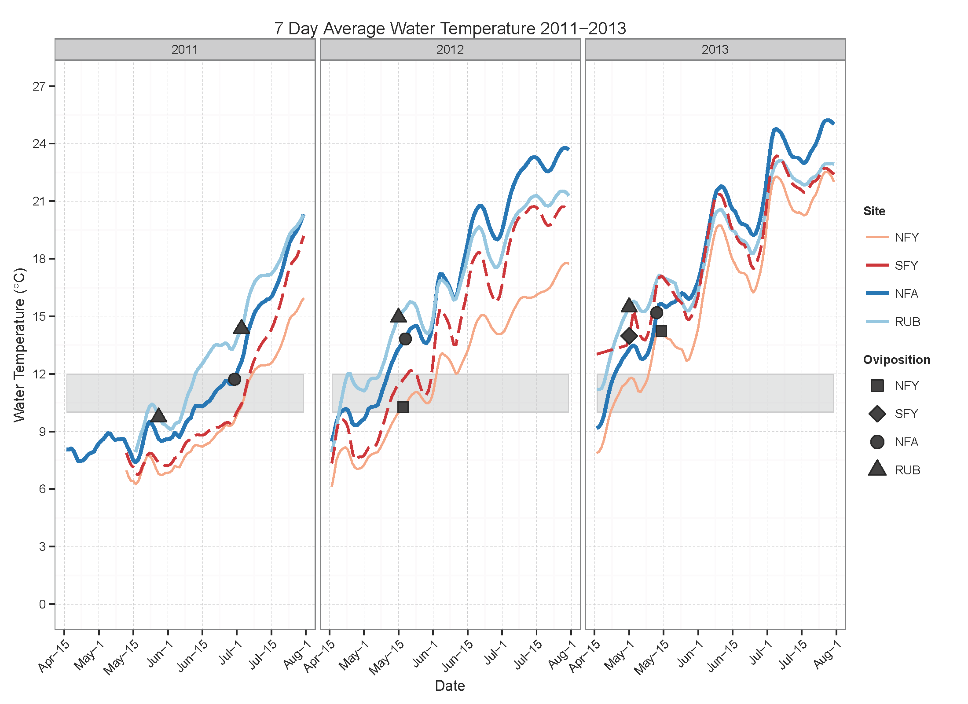

**Figure 7.**  Running seven-day mean daily water temperature (°C) and date of observed initiation of oviposition for selected study sites from 2011–2013. Gray shaded region indicates 10–12°C threshold.

Discussion

Management.—

We show that despite annual shifts in the timing and geographic disparities in underlying hydrologic drivers associated with rain or snow, R. boylii consistently begin oviposition when receding flows stabilize at a consistent rate of decline (4–6% per week) and average weekly water temperatures are greater than 10–12°C. Rana boylii have adapted to the predictability in stream conditions these environmental triggers provide, supplying both consistency for ontogeny as well as resilience to temporal variability as these cues oscillate over time.

Stream flow regulation can be particularly detrimental for *R. boylii* if it alters annual flow patterns by delaying, decreasing or augmenting flows, and thereby disrupting or eliminating the environmental cues *R. boylii* utilize (Figure 8). Wheeler and Welsh Jr. (2008) observed regulation of stream flows may alter breeding activity by advancing or delaying onset (initiation), shortening or lengthening duration and inundating calling sites for *R. boylii*. Kupferberg et al. (2009) found smaller sizes and later times to metamorphosis in the Mokelumne River as pulsed flows occurred later in the spring than would be expected under unregulated conditions. In regulated bypass reaches, flow patterns typically abbreviate or eliminate spring recession cues while maintaining constant flow during the low-flow period. During wet years, this can result in early oviposition when flow and water temperatures are suitable followed by scour of egg masses during subsequent late spring spills, as observed in the Rubicon River study site in 2011. In regulated rivers with hydropeaking or pulse flow regimes, ramping rates are often non-existent or much significantly higher than the 10 cm per week necessary for suitable *R. boylii* breeding and rearing conditions. On the MF American reach downstream of Oxbow Reservoir, daily fluctuations in flow between 200 and 1000 cfs create a 500 percent daily change in flow that equates to a meter or more of stage fluctuation (Figure 8). Combined with cold water temperatures from high-elevation reservoir releases upstream, the peaking reach of the MF American does not provide any suitable habitat for breeding or rearing. Without the predictable spring and summer flow conditions to which *R.boylii* have evolved, reproductive success may be limited in many regulated river reaches.

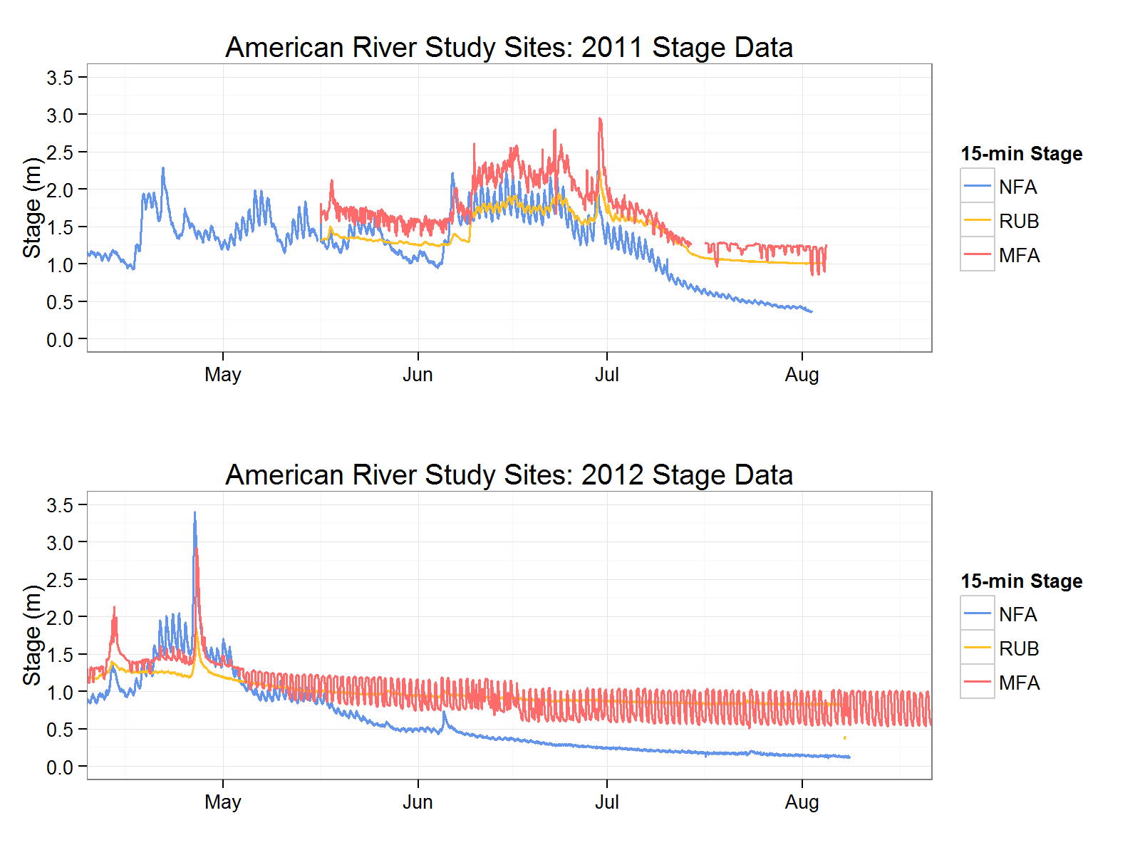

**Figure 8.** Fifteen-minute stage data from 2011 and 2012 for study sites in the American watershed. NFA=NF American, RUB=Rubicon, MFA=MF American.

In many regulated river systems however, particularly bypass reaches, flow management can be improved by restoring predictable flow regimes that mimic natural spring recessions. In bypass reaches, flows can be ramped down from spill at a rate of less than 10 cm per week or less than 10 percent per day, or a spring ecological flow pulse can be initiated with comparable recession characteristics. Similarly, supporting natural temperature regimes with 30-day maximum summer temperatures over 20°C (Catenazzi and Kupferberg 2013) can provide the ecological cues and instream habitat conditions *R. boylii* need for successful recruitment. Within the federal relicensing process for hydropower dams, there has been recent movement towards creating environmental flow prescriptions that mimic these natural flow regime characteristics in order to mitigate negative effects on sensitive native aquatic taxa such as *R. boylii* (Yarnell et al. 2013).

Summary.—For R. boylii, the most relevant cues driving plasticity in the initiation of breeding are decreasing rates of receding flow and increasing water temperature. Daily rates of receding flow were consistently less than 10 percent, and generally less than five percent during initiation of R. boylii oviposition in both Sierra and coastal populations. Analysis of long-term flow data from the NF American River shows remarkable consistency in average stage change during the spring recession, despite differing water year types and flow magnitudes—daily percent change in flow was less than 10 percent, and the mean weekly stage change was 0.09 m. Rana boylii oviposition has been repeatedly observed during this stable hydrological period on the NF American River, and this important environmental cue can be observed across rivers and regions. Similarly, weekly mean water temperatures greater than 10°C have consistently been observed during initiation of oviposition across years and watersheds. Therefore we suggest water temperature may serve as a threshold such that water temperatures must be greater than 10°C prior to oviposition, and flow stability, where daily recession rates are less than 10 percent, may serve as a trigger or cue for onset of breeding. When combined, these cues can help forecast suitable breeding conditions for R. boylii.

The natural variability in environmental cues such as water temperature and recession rate induces plasticity in *R. boylii* breeding, and may confer greater resilience over time. With climate warming, greater resilience may buffer population persistence in the face of shifts in both timing and magnitude of temperature and flow. Depending on the basin, the timing of the spring-snowmelt recession is predicted to occur two to four weeks earlier, the magnitude will be reduced as more precipitation falls in the form of rain, and earlier snowmelt over the same duration will result in longer periods of low flow during the dry season (Rheinheimer et al. 2012). In regulated systems, continued changes in (or absence of) these flows may reduce resilience in populations as biologically predictable patterns are lost, forcing populations to retreat to tributaries where seasonal flow clues are retained. As climate change continues to alter hydroclimatic conditions, tributaries may be critical units for watershed management, particularly in regulated reaches.

*R. boylii* is a unique and highly suitable indicator species, as not only a link between both aquatic and riparian ecosystems, but as a sensitive gage of the natural seasonal hydrology in riverine environments. Changes in the hydrology of a system can greatly alter this species’ ability to persist, thus conservation efforts should focus on restoring and maintaining key environmental cues within the natural flow regime.

*Acknowledgements.—*We thank Amy Lind for her contribution to this manuscript, and all the field crew at Center for Watershed Sciences that assisted in data collection. This research

was conducted with the approval of California Department of Fish and Game (Permit #s SC-006881, SC-009327).

Literature Cited

Alford, R.A. and R.N. Harris. 1988. Effects of larval growth history on anuran metamorphosis. American Naturalist 131:91–106.

Barnett, H. and J. Richardson. 2002. Predation risk and competition effects on the life-history characteristics of larval Oregon spotted frog and larval red-legged frog. Oecologia 132:436–444.

Beebee, T.J.C. and R.A. Griffiths. 2005. The amphibian decline crisis: A watershed for conservation biology? Biological Conservation 125:271–285.

Benda, L., K. Andras, D. Miller and P. Bigelow. 2004. Confluence effects in rivers: Interactions of basin scale, network geometry, and disturbance regimes. Water Resources Research 40:1–15.

Beschta, R.L., R.E. Bilby, G.E. Brown, L.B. Holtby and T.D. Hofstra. 1987. Pp. 191–232 *In* Streamside Management: Forest and Fishery Interactions. E.O. Salo and T.W. Cundy (Eds.). University of Washington, Institute of Forest Resources,

Bondi, C., S. Yarnell and A. Lind. 2013. Transferability of Habitat Suitability Criteria for a Stream Breeding Frog (*Rana boylii*) in the Sierra Nevada, California. Conservation and Biology 8:88–103.

Catenazzi, A. and S.J. Kupferberg. 2013. The importance of thermal conditions to recruitment success in stream-breeding frog populations distributed across a productivity gradient. Biological Conservation 168:40–48.

Davidson, C., H.B. Shaffer and M.R. Jennings. 2002. Spatial tests of the pesticide drift, habitat destruction, UV-B, and climate-change hypotheses for California amphibian declines. Conservation Biology 16:1588–1601.

Denver, R.J., N. Mirhadi and M. Phillips. 1998. Adaptive plasticity in amphibian metamorphosis: Response of *Scaphiopus hammondii* tadpoles to habitat desiccation. Ecology 79:1859–1872.

Eaton, J., J. McCormick, B. Goodno, D. O'Brien, H. Stefany, M. Hondzo and R. Scheller. 1995. A field information-based system for estimating fish temperature tolerances. Fisheries 20:10–18.

Epke, G.A. 2011. Spring Snowmelt Recession in Rivers of the Western Sierra Nevada Mountains. M.Sc. Thesis, University of California Davis, California, USA, 67 p.

Gomez-Mestre, I., J.J. Wiens and K.M. Warkentin. 2008. Evolution of adaptive plasticity: Risk-sensitive hatching in neotropical leaf-breeding treefrogs. Ecological Monographs 78:205–224.

Gonsolin, E. 2010. Ecology of Foothill Yellow-legged Frogs in Upper Coyote Creek, Santa Clara County, CA. M.Sc. Thesis Biology, San Jose State University, California, USA, 119 p.

Gotthard, K. and S. Nylin. 1995. Adaptive plasticity and plasticity as an adaptation: a selective review of plasticity in animal morphology and life history. Oikos 7:3–17.

Grantham, T.E., A.M. Merenlender and V.H. Resh. 2010. Climatic influences and anthropogenic stressors: an integrated framework for streamflow management in Mediterranean‐climate California, USA. Freshwater Biology 55:188–204.

Jakob, C., G. Poizat, M. Veith, A. Seitz and A. Crivelli. 2003. Breeding phenology and larval distribution of amphibians in a Mediterranean pond network with unpredictable hydrology. Hydrobiologia 499:51–61.

Jennings, M., M. Hayes and D. of Fish and Game. 1994. Amphibian and Reptile Species of Special Concern in California. California Department of Fish and Game

Keefer, M.L., C.A. Peery and C.C. Caudill. 2008. Migration timing of Columbia River spring Chinook salmon: effects of temperature, river discharge, and ocean environment. Transactions of the American Fisheries Society 137:1120–1133.

Kupferberg, S.J. 1996. Hydrologic and geomorphic factors affecting conservation of a river-breeding frog (*Rana boylii*). Ecological Applications 6:1332–1344.

Kupferberg, S.J. 1997. Bullfrog (*Rana catesbeiana*) invasion of a California river: The role of larval competition. Ecology 78:1736–1751.

Kupferberg, S.J., A.J. Lind and J.F. Mount. 2008. Pulsed Flow Effects on the Foothill Yellow-Legged Frog (*Rana boylii*): Integration of Empirical, Experimental, and Hydrodynamic Modeling Approaches. PIER 194.

Kupferberg, S.J., A.J. Lind and W.J. Palen. 2009. Pulsed Flow Effects on The Foothill Yellow-Legged Frog (*Rana boylii*): Population Modeling. PIER, (Publication number 500-2009-002a). 1–92 p.

Kupferberg, S.J., W.J. Palen, A.J. Lind, S. Bobzien, A. Catenazzi, J. Drennan and M.E. Power. 2012. Effects of Flow Regimes Altered by Dams on Survival, Population Declines, and Range-Wide Losses of California River-Breeding Frogs. Conservation Biology 26:513–524.

Laurila, A. and J. Kujasalo. 1999. Habitat duration, predation risk and phenotypic plasticity in common frog (*Rana temporaria*) tadpoles. Journal of Animal Ecology 68:1123–1132.

Lind, A.J. 2005. Reintroduction of a Declining Amphibian: Determining an Ecologically Feasible Approach for the Foothill Yellow-legged Frog (*Rana boylii*) Through Analysis of Decline Factors, Genetic Structure, and Habitat Associations. Ph.D. Dissertation, University of California, Davis, California, USA, 169 p.

Lind, A.J., H.H. Welsh and R.A. Wilson. 1996. The effects of a dam on breeding habitat and egg survival of the Foothill yellow-legged frog (*Rana boylii*) in northwestern California. Herpetological Review 27:62–67.

Lind, M.I. and F. Johansson. 2007. The degree of adaptive phenotypic plasticity is correlated with the spatial environmental heterogeneity experienced by island populations of *Rana temporaria*. Journal of Evolutionary Biology 20:1288–1297.

Lytle, D.A. and N.L. Poff. 2004. Adaptation to natural flow regimes. Trends Ecol Evol 19:94–100.

Marchetti, M.P. and P.B. Moyle. 2001. Effects of flow regime on fish assemblages in a regulated California stream. Ecological Applications 11:530–539.

Matthews, K. and K. Pope. 1999. A telemetric study of the movement patterns and habitat use of *Rana muscosa*, the mountain yellow-legged frog, in a high-elevation basin in Kings Canyon National Park, California. Journal of Herpetology 33:615–624.

Merilae, J., A. Laurila, M. Pahkala and K. Raesaenen. 2000. Adaptive phenotypic plasticity in timing of metamorphosis in the common frog *Rana temporaria*. Ecoscience 7:18–24.

Michel, M.J. 2012. Phenotypic plasticity in complex environments: effects of structural complexity on predator- and competitor-induced phenotypes of tadpoles of the wood frog, *Rana sylvatica*. Biological Journal of the Linnean Society 105:853–863.

Moyle, P.B., J.V.E. Katz and R.M. Quinones. 2011. Rapid decline of California's native inland fishes: A status assessment. Biological Conservation 144:2414–2423.

Naiman, R.J., H. Decamps, J. Pastor and C.A. Johnston. 1988. The potential importance of boundaries of fluvial ecosystems. Journal of the North American Benthological Society 289–306.

Nelitz, M.A., E.A. MacIsaac and R.M. Peterman. 2007. A science-based approach for identifying temperature-sensitive streams for rainbow trout. North American Journal of Fisheries Management 27:405–424.

Neuheimer, A.B. and C.T. Taggart. 2007. The growing degree-day and fish size-at-age: the overlooked metric. Canadian Journal of Fisheries and Aquatic Sciences 64:375–385.

Newman, R.A. 1992. Adaptive plasticity in amphibian metamorphosis. BioScience 42:671–678.

Nicol, S. 2006. Krill, currents, and sea ice: Euphausia superba and its changing environment. BioScience 56:111–120.

Null, S.E., J.H. Viers, M.L. Deas, S.K. Tanaka and J.F. Mount. 2013. Stream temperature sensitivity to climate warming in California's Sierra Nevada: impacts to coldwater habitat. Climatic Change 116:149–170.

Orizaola, G. and A. Laurila. 2009. Microgeographic variation in temperature-induced plasticity in an isolated amphibian metapopulation. Evolutionary Ecology 23:979–991.

Poff, N.L., J.D. Allan, M.B. Bain, J.R. Karr, K.L. Prestegaard, B.D. Richter, R.E. Sparks and J.C. Stromberg. 1997. The natural flow regime. BioScience 47:769–784.

Poff, N.L., M.I. Pyne, B.P. Bledsoe, C.C. Cuhaciyan and D.M. Carlisle. 2010. Developing linkages between species traits and multiscaled environmental variation to explore vulnerability of stream benthic communities to climate change. Journal of the North American Benthological Society 29:1441–1458.

Power, M.E., W.E. Dietrich and J.C. Finlay. 1996. Dams and Downstream Aquatic Biodiversity: Potential Food Web Consequences of Hydrologic and Geomorphic Change. Environmental Management 20:887–895.

Reed, T.E., R.S. Waples, D.E. Schindler, J.J. Hard and M.T. Kinnison. 2010. Phenotypic plasticity and population viability: the importance of environmental predictability. Proceedings of the Royal Society B: Biological Sciences 277:3391–3400.

Rehn, A.C. 2009. Benthic macroinvertebrates as indicators of biological condition below hydropower dams on west slope Sierra Nevada streams, California, USA. River Research and Applications 25:208–228.

Relyea, R. 2002. Local population differences in phenotypic plasticity: predator-induced changes in wood frog tadpoles. Ecological Monographs 72:77–93.

Rheinheimer, D.E., S. Yarnell and J. Viers. 2012. Hydropower Costs of Environmental Flows and Climate warming in California's Upper Yuba River watershed. River Research and Applications 29:1291–1305.

Richardson, J. 2002. A comparative study of phenotypic traits related to resource utilization in anuran communities. Evolutionary Ecology 16:101–122.

Rudolf, V.H. and M.O. Rodel. 2005. Oviposition site selection in a complex and variable environment: the role of habitat quality and conspecific cues. Oecologia 142:316–325.

Saenz, D., L.A. Fitzgerald, K.A. Baum, R.N. Conner and D. Adams. 2006. Abiotic correlates of anuran calling phenology: the importance of rain, temperature, and season. Herpetological Monographs 20:64–82.

Sinervo, B. and S.C. Adolph. 1994. Growth Plasticity and Thermal Opportunity in Sceloporus Lizards. Ecology 75:776–790.

Stebbins, R.C. 2003. A field guide to western reptiles and amphibians. Houghton Mifflin, Boston.

Storer, T. 1925. A synopsis of the amphibia of California. University of California Publications in Zoology 27:1–342.

Timm, B.C., K. McGarigal and B.W. Compton. 2007. Timing of large movement events of pond-breeding amphibians in Western Massachusetts, USA. Biological Conservation 136:442–454.

Tufto, J. 2000. The evolution of plasticity and nonplastic spatial and temporal adaptations in the presence of imperfect environmental cues. The American Naturalist 156:121–130.

Werner, E.E. 1986. Amphibian metamorphosis: growth rate, predation risk, and the optimal size at transformation. American Naturalist 128:319–341.

Wheeler, C. 2007. Temporal breeding patterns and mating strategy of the Foothill yellow-legged frog (*Rana boylii*). M.Sci. Thesis, Humbold State University, California, USA, 52 p.

Wheeler, C.A. and H.H. Welsh Jr. 2008. Mating Strategy and Breeding Patterns of the Foothill Yellow-Legged Frog (*Rana Boylii*). Herpetological Conservation and Biology 3:128–142.

Yarnell, S.M., A.J. Lind and J.F. Mount. 2012. Dynamic flow modelling of riverine amphibian habitat with application to regulated flow management. River Research and Applications 28:177–191.

Yarnell, S.M., R.A. Peek, D.E. Rheinheimer, A.J. Lind and J.H. Viers. 2013. Management of the Spring Snowmelt Recession: An Integrated Analysis of Empirical, Hydrodynamic, and Hydropower Modeling Applications. California Energy Commission, PIER, CEC-500-2011-TBD 63 p.

Yarnell, S.M., J.H. Viers and J.F. Mount. 2010. Ecology and Management of the Spring Snowmelt Recession. BioScience 60:114–127.

Zweifel, R.G. 1955. Ecology, distribution, and systematics of frogs of the Rana boylei group. University of California Publications in Zoology 54:207–291.

**RYAN A. PEEK** is a Staff Research Associate at the Center for Watershed Sciences at UC Davis and is starting a Ph.D. in Ecology at UC Davis. He received a Master’s degree in Biology from the University of San Francisco and a B.Sci. in Wildlife, Fish, & Conservation Biology from UC Davis. His primary research interests include amphibian ecology and freshwater conservation, with a focus on identifying functional components of ecosystem resilience in the face of climate warming and intensive watershed use. Research projects include assessing genetic connectivity and breeding ecology of Foothill yellow-legged frogs (*R. boylii*) in hydropower regulated rivers; characterizing the effects of spring snowmelt on biotic and abiotic stream conditions in the Sierra Nevada; and identifying and prioritizing freshwater conservation across California using PISCES. His current research investigates the role of water chemistry in spatiotemporal biodiversity using environmental DNA in the North Yuba River. (Photographed by Sarah Yarnell)

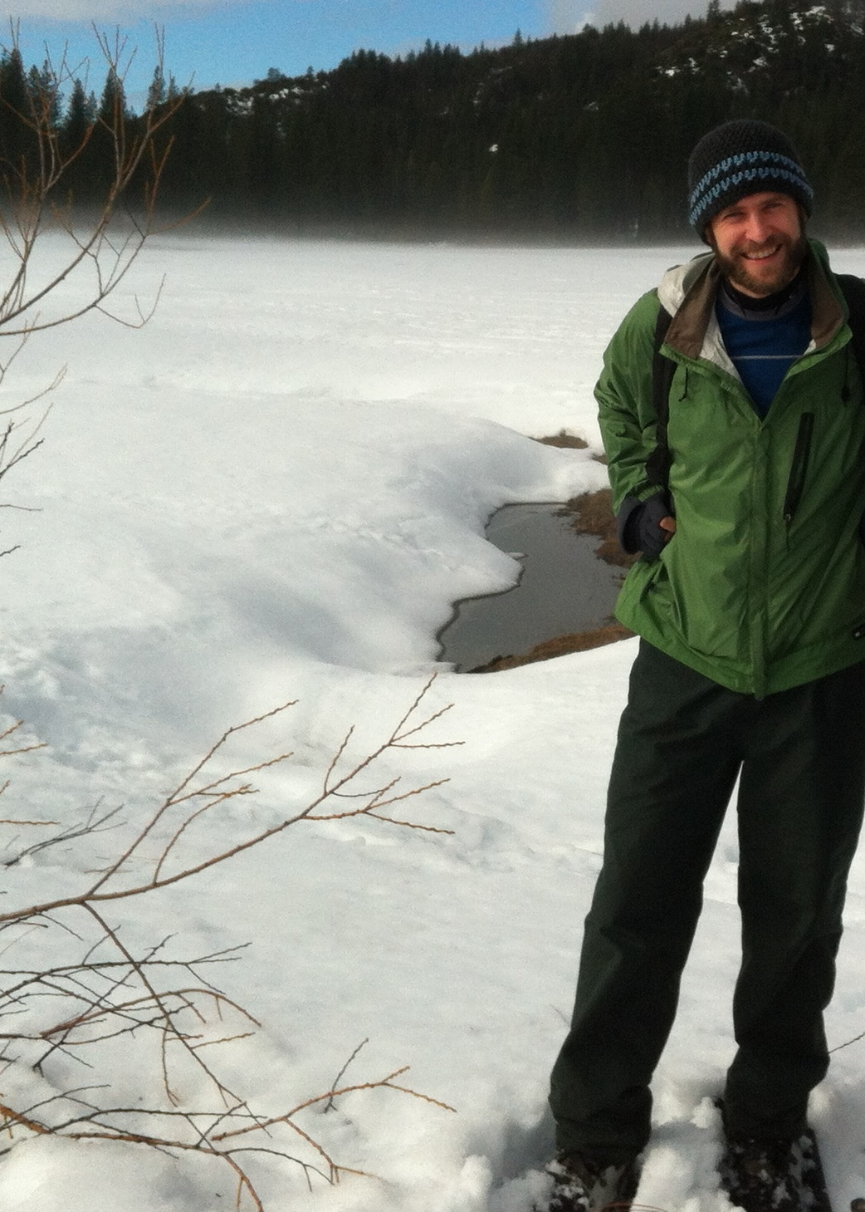

**SARAH M. YARNELL** is an Assistant Project Scientist at the Center for Watershed Sciences at UC Davis. Her studies focus on integrating the traditional fields of hydrology, ecology and geomorphology in the river environment. She is currently conducting research that applies understanding of river ecosystem processes to managed systems in the Sierra Nevada, with a focus on the development and maintenance of riverine habitat. She is a recognized expert in the ecology of the Foothill Yellow-legged Frog, a California species of special concern, and she is the first researcher to apply sediment transport and two-dimensional hydrodynamic modeling techniques to the evaluation of instream amphibian habitat. More recently, her experience has expanded to include consultation as a technical expert for various hydroelectric power relicensing projects (Big Creek Project, Desabla-Centerville Project, Middle Fork American Project, Yuba-Bear/Drum-Spaulding Project), where she has worked closely with government resource agencies and the private sector to assess the impacts of environmental flows on

aquatic biota. (Photographed by Jeff Mount)

